WEB APPLICATION SECURITY REPORT

Objective:
The objective of this task is to identify and demonstrate common web application security vulnerabilities in a controlled DVWA laboratory environment and understand their corresponding mitigation techniques.

Lab Environment:
Operating System | Kali Linux
Target Application | DVWA
Deployment | Docker
Target URL | http://localhost:4280
Testing Tool | Burp Suite Community Edition
Browser | Burp Browser / Firefox
Environment | Local controlled lab

1.SQL Injection

Objective:
To demonstrate SQL Injection in DVWA and understand how an attacker can manipulate an SQL query through user input.

INPUT: 1’ OR ‘1’ = ‘1

Observed Result: Application returned multiple records.

Impact: An attacker may manipulate the SQL query and access unauthorized database information.

Root Cause: User input is added into the SQL query without proper sanitization.

Mitigation: Use prepared statements / parameterized queries.
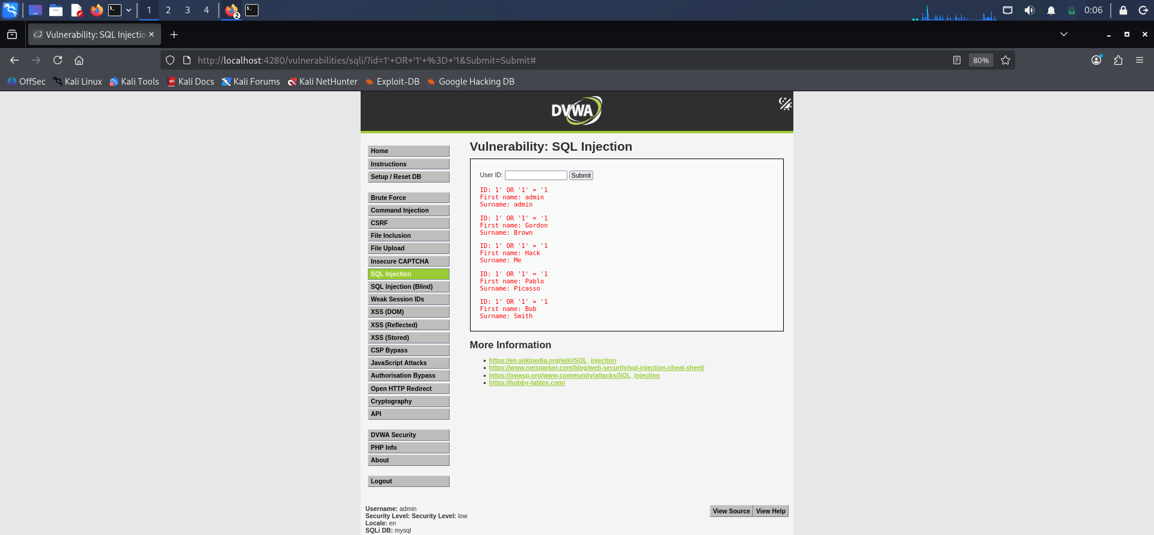

Demonstrating prevention using Prepared Statements

For Example:

$query = "SELECT * FROM users WHERE id = '$id'";

The above one is a malicious query, The application directly places the user's input into the SQL query. Therefore, an attacker can manipulate the query.
Prepared statement is:
$stmt = $pdo->prepare(
"SELECT * FROM users WHERE id = ?"
);

$stmt->execute([$id]);
The above code is secure and it sanitizes the user’s input, A prepared statement separates the SQL command from the user input. The input is treated as data rather than SQL code, which prevents the SQL injection demonstrated earlier.

2.XSS Report

Stored XSS (Cross site scripting)

Objective:
To identify and demonstrate a Stored Cross-Site Scripting (XSS) vulnerability in DVWA.

Payload Used:
<script>alert('Stored XSS')</script>

Steps:
- Opened DVWA → XSS (Stored).
- Entered the above payload in the input field.
- Submitted the input.
- The payload was stored by the application.
- When the page was loaded, a JavaScript alert appeared.

Observation:
The payload was stored by the application and the JavaScript alert was executed when the page was loaded, confirming a Stored XSS vulnerability.

Impact:
An attacker could potentially execute malicious JavaScript in the browser of users who view the affected content.

Mitigation:
- Input Validation: Validate and sanitize user input before storing or displaying it. Reject or safely encode unexpected HTML/JavaScript.
- Content Security Policy (CSP): Implement a strong CSP to restrict which scripts can execute in the browser.
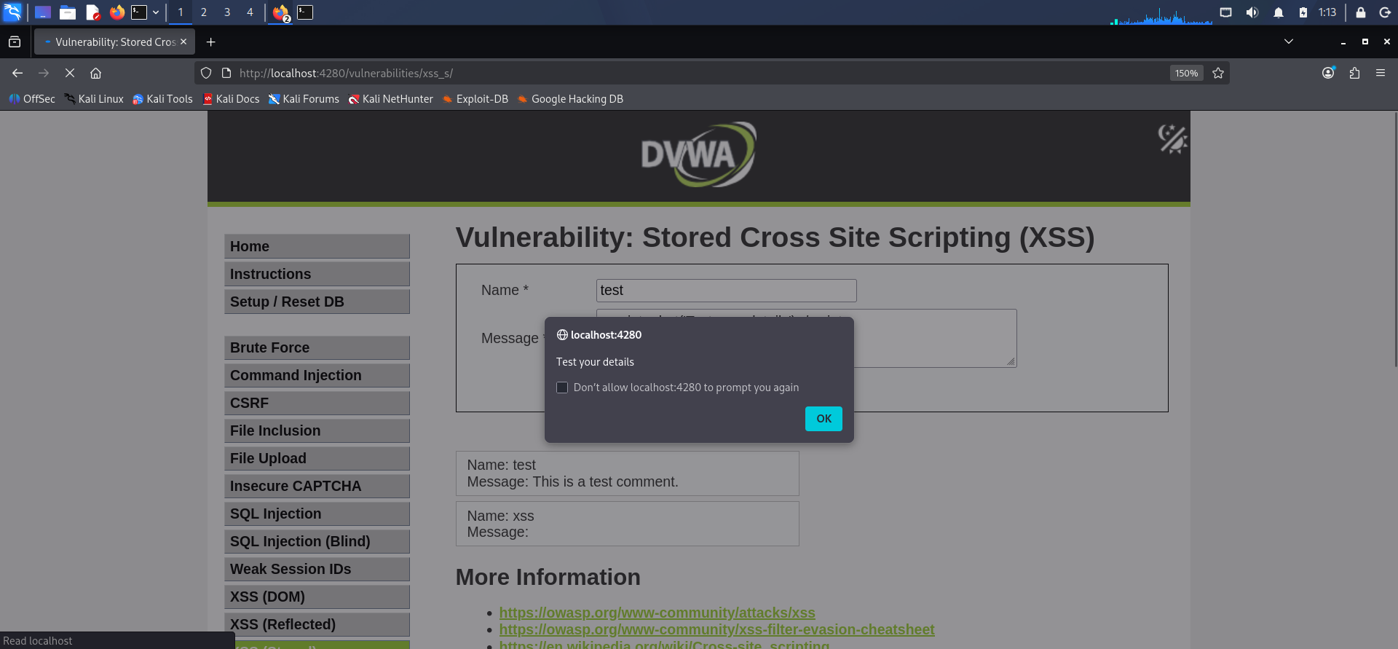

Conclusion:
Stored XSS was successfully demonstrated in the DVWA lab environment.

Reflected XSS (Cross site scripting)

Objective:
Demonstrate reflected cross-site scripting through a URL query parameter.
Normal input: Alice
Parameter: name
Test payload:
<script>alert('check your details.')</script>
Observation:
The payload was supplied through the name query parameter and was reflected by the vulnerable application. The browser interpreted the reflected input as JavaScript and displayed an alert.
Impact:
If exploitable in a real application, reflected XSS could allow attacker-controlled JavaScript to execute in a victim's browser under the application's origin.
Mitigation:
Use context-appropriate output encoding, validate input where appropriate, and apply defense-in-depth controls such as Content Security Policy.

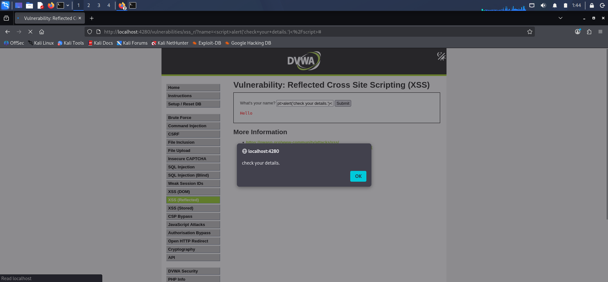

Conclusion:
Reflected XSS was successfully demonstrated in the DVWA lab environment.

3.CSRF(Cross-Site Request Forgery)

Vulnerability: CSRF(CROSS-SITE REQUEST FORGERY)

Affected Function: Password change

Impact: An attacker may cause an authenticated victim's browser to perform an unwanted state-changing action.

Root Cause: The application does not verify that the request originated from the legitimate application context.

Mitigation: Use predictable anti-CSRF tokens and appropriate cookie/request protections.

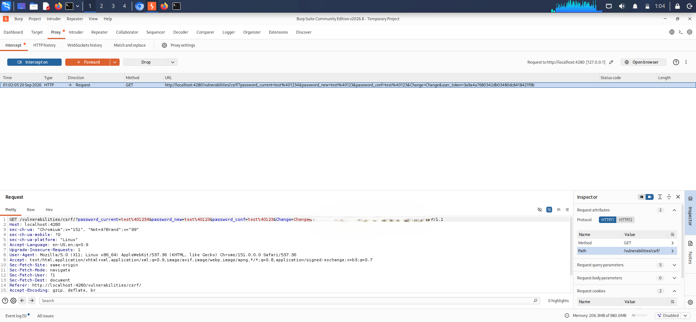

Without CSRF token:
Attacker request → Server accepts request → Action happens
With CSRF token:
Attacker request → Server checks token → Token missing/incorrect → Request rejected
Observation:
The CSRF-protected request contains a unique security token. The server validates this token before processing the state-changing request. When the token is missing or invalid, the request is rejected, preventing an attacker from successfully forging the request.
Protection mechanism:
A CSRF token is a random, unpredictable value associated with the user's session. A legitimate form includes this token, and the server verifies it when the request is submitted.

4.File Inclusion
File Inclusion vulnerabilities occur when an application uses user-controlled input to determine which file should be included or accessed. Depending on the application's configuration, this can lead to unauthorized file access or, in some cases, execution of malicious code.
Local File Inclusion
Local File Inclusion (LFI) occurs when an application allows a user-controlled parameter to determine a local file that the server includes or reads.
In the controlled DVWA laboratory environment, an LFI test was performed using the File Inclusion functionality. A local file path was supplied through the vulnerable parameter, and the application's response was observed.
The application generated an error/output indicating that the requested local file was being processed by the application.
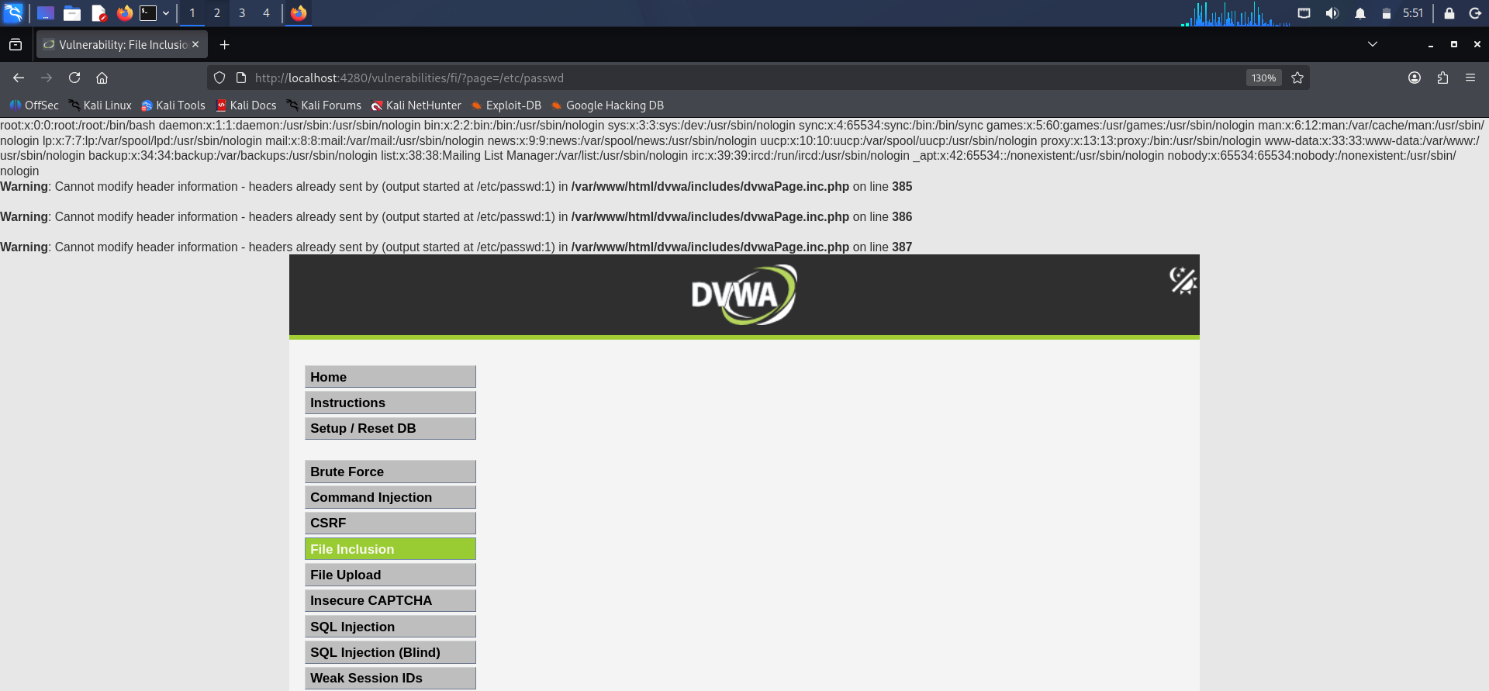

Observation
The test demonstrated that user-controlled input could influence the file selected by the application. The resulting error/output provided evidence of how the application handled the supplied local file path.

Mitigation
The following measures can help prevent LFI vulnerabilities:
- Sanitize all user-controlled input.
- Use an allowlist of permitted files instead of accepting arbitrary file paths.
- Avoid using user input directly in file inclusion functions.
- Avoid exposing sensitive system files to the web application.
- Use secure application logic that maps user input to predefined resources.

Remote File Inclusion
Remote File Inclusion (RFI) occurs when an application allows a remotely located resource to be included. In a vulnerable configuration, this can potentially result in execution of attacker-controlled code.
A controlled RFI demonstration was performed in the isolated DVWA laboratory environment. A harmless test resource was used to observe how the application handled a remotely specified resource.
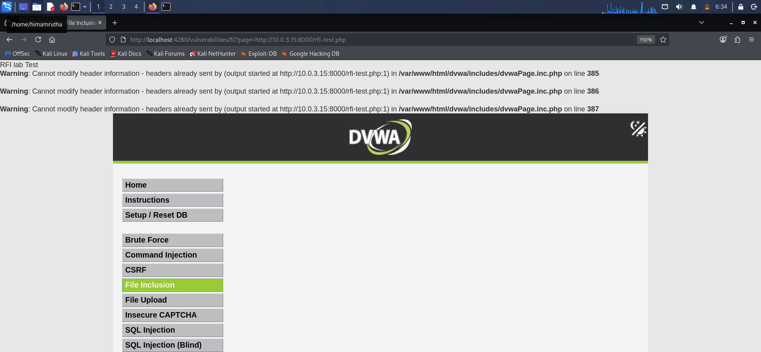

Observation
The test demonstrated the application's behavior when a remotely located resource was supplied through the vulnerable parameter. The result was observed only within the controlled laboratory environment.

Mitigation
The following measures can help prevent RFI vulnerabilities:
- Validate and sanitize user input.
- Use an allowlist of permitted files and resources.
- Avoid user-controlled file paths and URLs.
- Disable remote file inclusion functionality when it is not required.
- Disable unnecessary URL-based file inclusion settings in the server-side environment.
- Apply the principle of least privilege to the web application's account.

5.Burp Suite Advanced
Burp Suite was used as an interception and testing tool within the controlled DVWA laboratory environment. It allowed HTTP requests generated by the application to be captured, inspected, modified, and forwarded.

Intercept and Modify Login Request
Burp Suite Proxy was used to intercept an HTTP request generated by the DVWA application. The request was inspected and modified within the controlled laboratory environment before being forwarded to the application.
The intercepted request allowed the HTTP method, parameters, headers, and other request information to be examined.

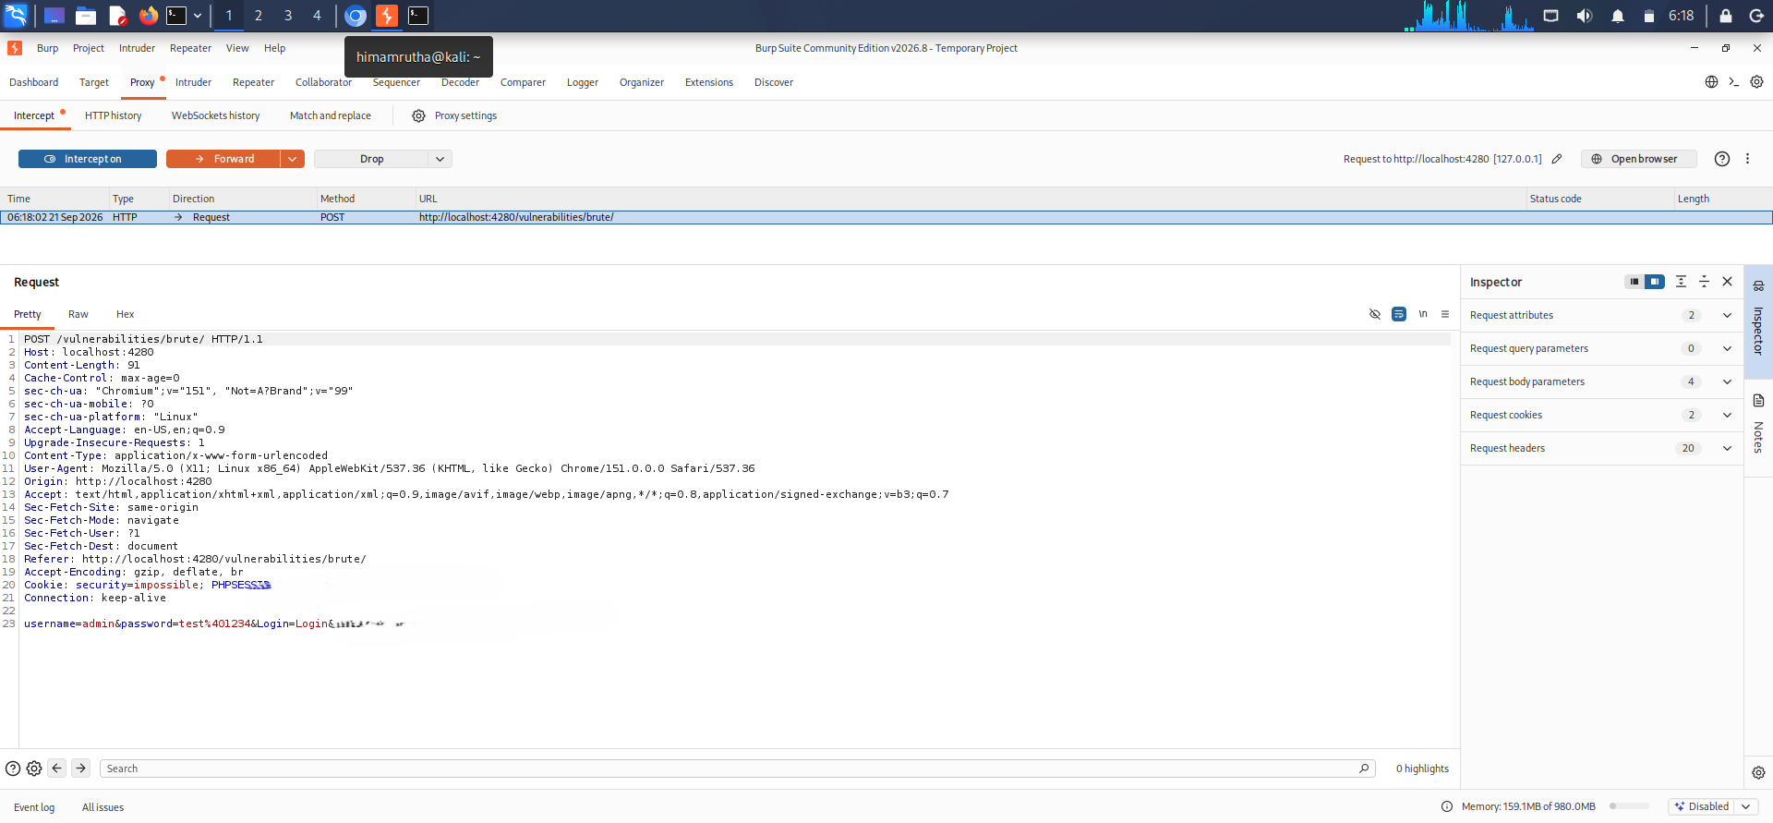
MODIFIED LOGIN CREDENTIALS
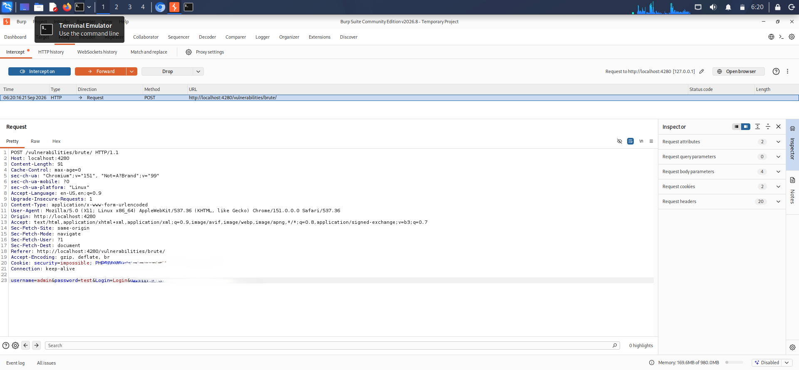

Observation
The intercepted request showed the parameters submitted by the browser to the DVWA application. A parameter was modified in the controlled lab and the modified request was forwarded to the application to observe the resulting response.
The resulting response comes such as password is invalid as shown in the below figure.
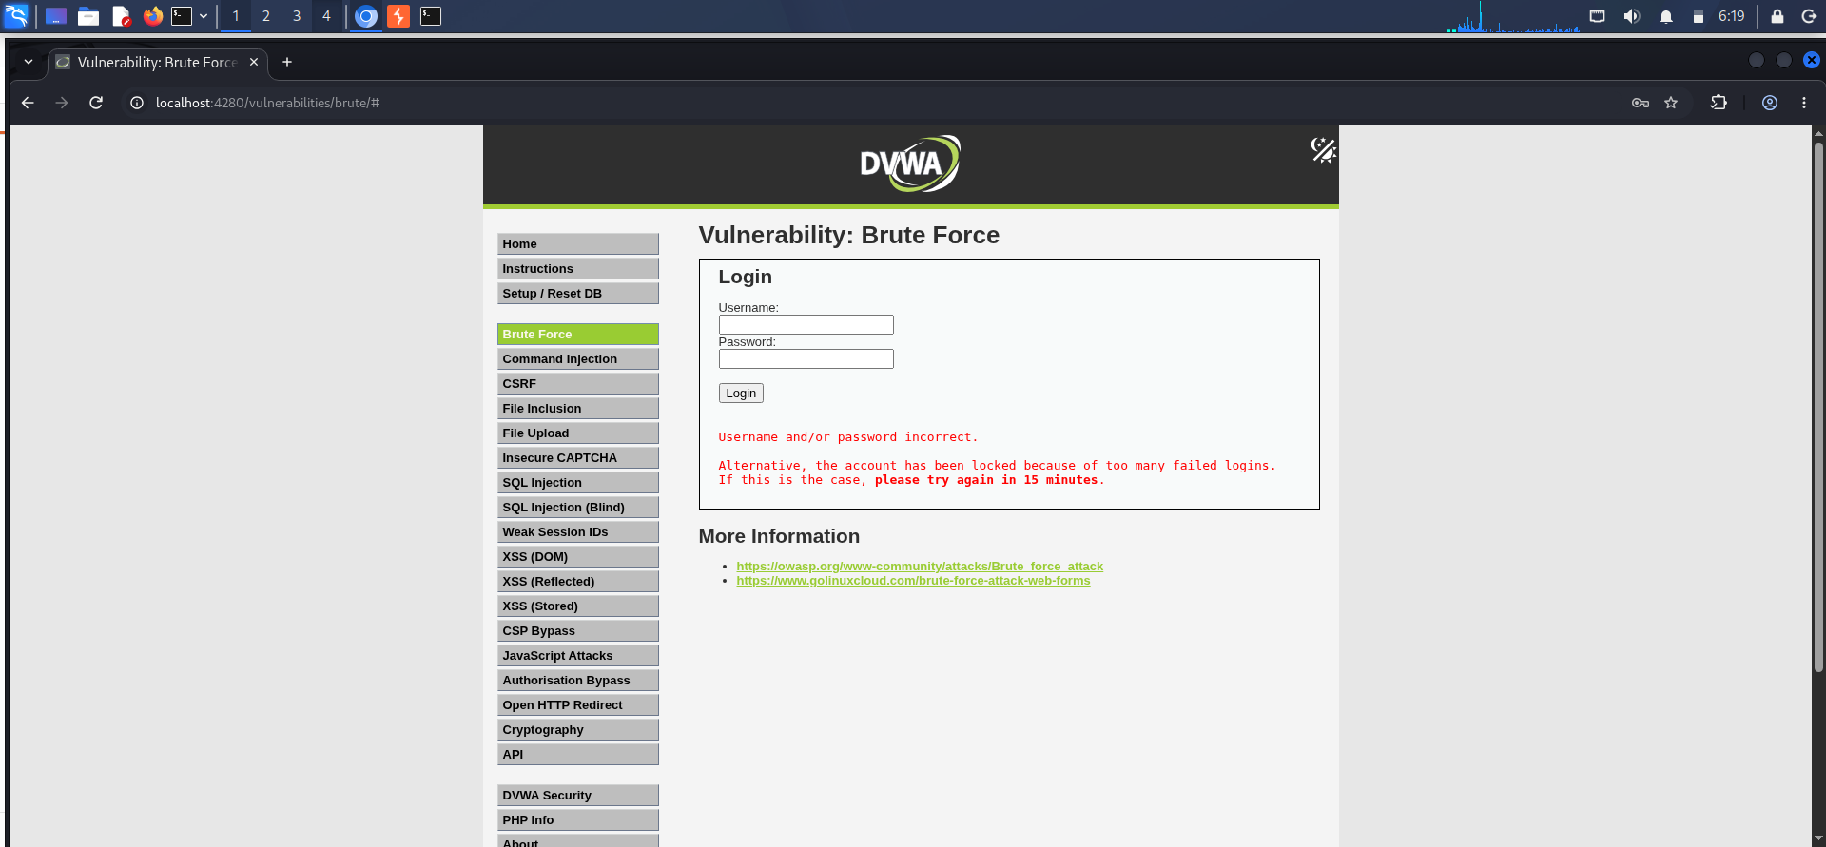
This demonstrated how Burp Suite can be used to analyze and test HTTP requests during web application security testing.

Security Relevance
Intercepting and modifying requests is useful for identifying issues such as:
- Improper input validation
- Parameter manipulation
- Authentication weaknesses
- Authorization problems
Testing was performed only against the locally hosted DVWA application.

Intruder Fuzzing
Burp Suite Intruder was used to perform a small and controlled fuzzing demonstration against the local DVWA application.
The request was first sent from the Proxy/HTTP history to Intruder. A parameter was selected as the payload position, and a small test payload list was configured.
The test process included:
- Sending the selected request to Intruder.
- Selecting the parameter to be tested.
- Marking the parameter as the payload position.
- Configuring a small test payload list.
- Starting the controlled Intruder attack.
- Comparing the responses returned for the different payloads.
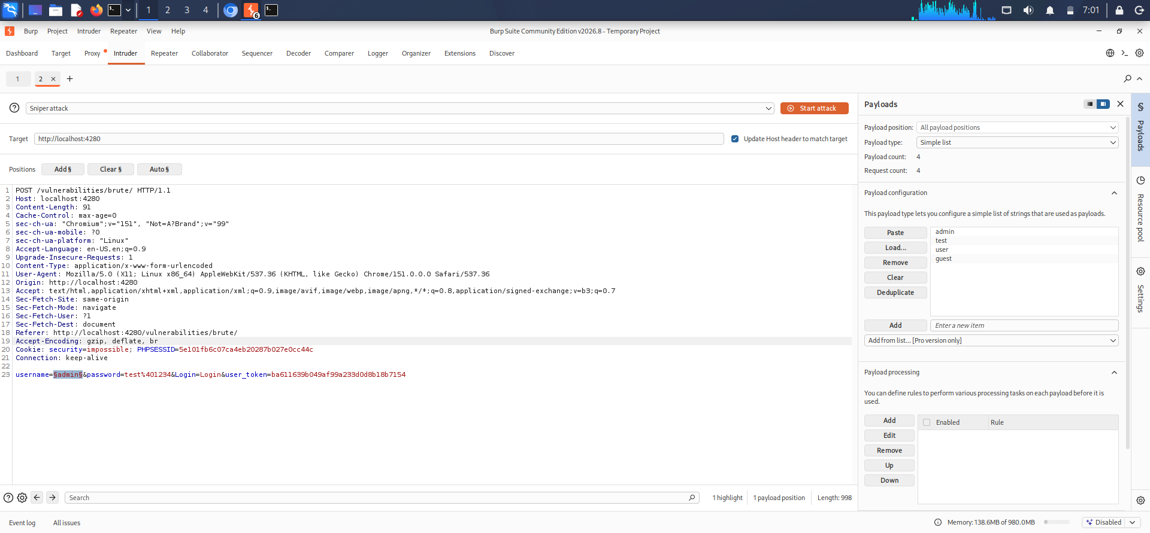
Burp Suite Intruder payload configuration
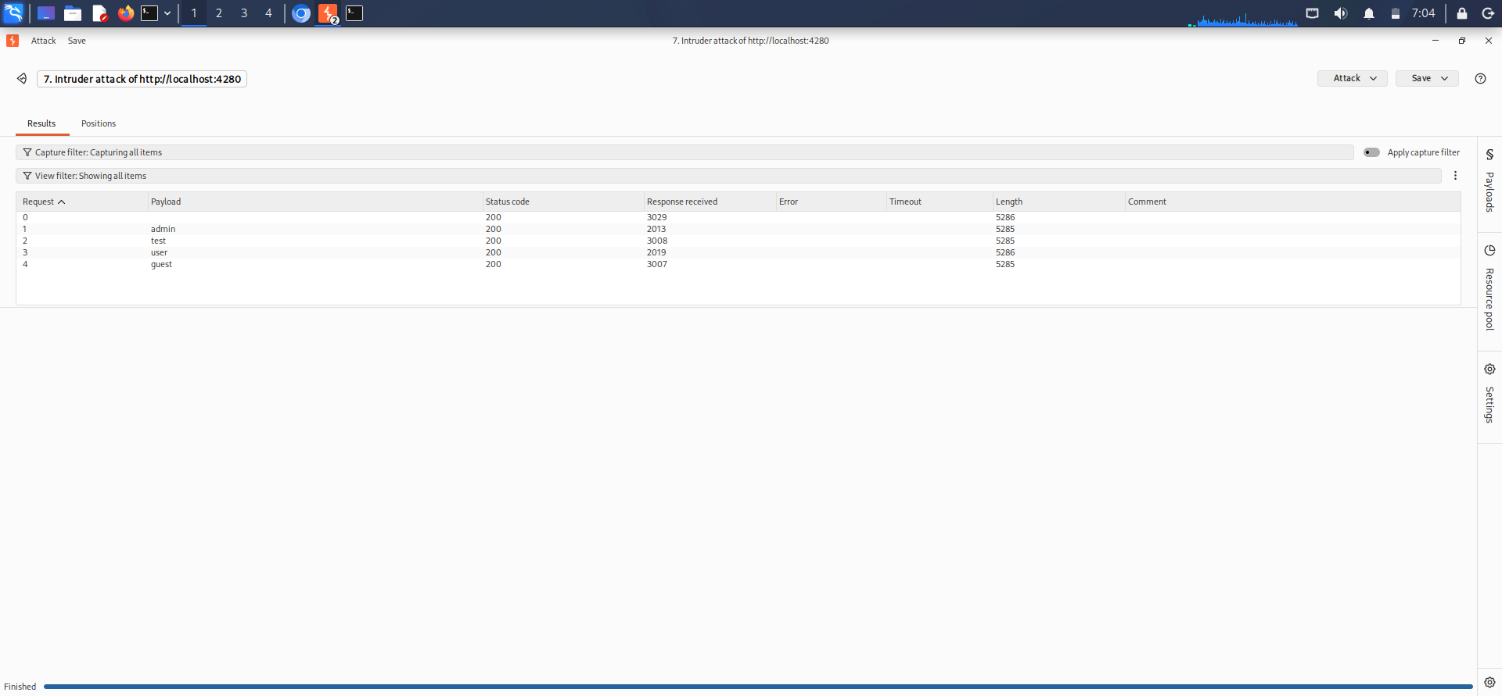
Intruder fuzzing results

Observation
The Intruder results showed how different input values produced different HTTP responses from the application. Response status codes, response lengths, and other response characteristics can be compared to identify unusual behavior.

Security Relevance
Fuzzing can help security testers identify:
- Unexpected input handling
- Input validation weaknesses
- Parameter-related vulnerabilities
- Different application responses to different inputs
The fuzzing demonstration was kept small and controlled because the testing was performed against a local DVWA laboratory environment.

Mitigation
- Validate input on the server side.
- Apply appropriate input length and format restrictions.
- Reject unexpected or malformed input.
- Use parameterized queries where database input is involved.
- Implement proper authentication and authorization controls.
- Log suspicious or repeated invalid requests.

6.Web Security Headers
HTTP security headers are response headers that provide additional security controls between a web application and the user's browser. They can help reduce the impact of attacks such as cross-site scripting(XSS) etc …,
The HTTP response headers of the local DVWA application were analyzed using:
[curl -I http://127.0.0.1]
The response included security-related headers such as:
- X-Content-Type-Options: nosniff
- X-Frame-Options: SAMEORIGIN
- Referrer-Policy: strict-origin-when-cross-origin

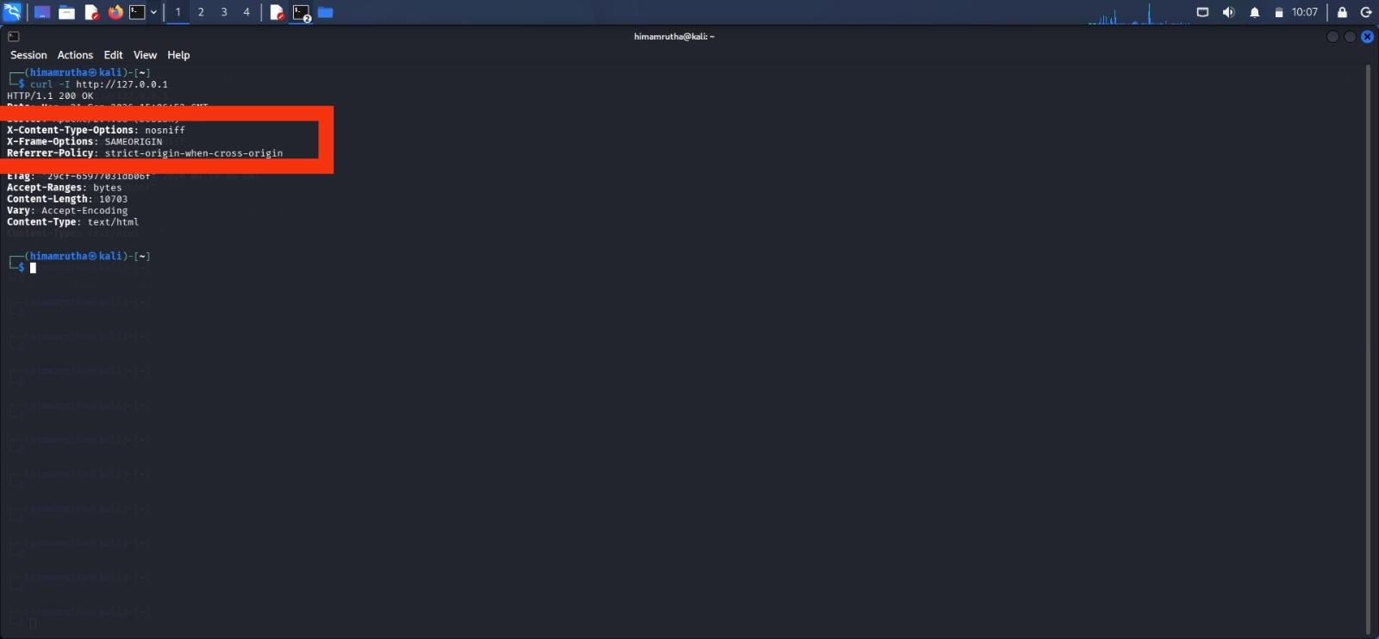
HTTP security headers observed using curl

9.1 Security Header Analysis
Header | Purpose
X-Content-Type-Options | Helps prevent MIME-type sniffing by instructing the browser to respect the declared content type.
X-Frame-Options | Controls whether the application can be loaded inside a frame or iframe and helps reduce clickjacking risks.
Referrer-Policy | Controls how much referrer information is included when the browser makes requests to other resources.

Observation
The curl command was used to inspect the HTTP response headers returned by the local application.
The response showed the following configured security headers:
- X-Content-Type-Options: nosniff
- X-Frame-Options: SAMEORIGIN
- Referrer-Policy: strict-origin-when-cross-origin
These headers provide additional browser-side security protections.

Mitigation / Recommended Security Headers
- X-Content-Type-Options

X-Content-Type-Options: nosniff

This helps prevent browsers from interpreting a resource as a different MIME type than the one declared by the server.

X-Frame-Options
X-Frame-Options: SAMEORIGIN
This helps prevent unauthorized framing of the application and reduces clickjacking risks.

Referrer-Policy
Referrer-Policy: strict-origin-when-cross-origin
can limit the amount of referrer information exposed to other websites.

Content-Security-Policy
A suitable CSP should be configured according to the application's requirements. CSP can restrict which scripts, styles, images, and other resources the browser is allowed to load.

Example:
Content-Security-Policy: default-src 'self'

Strict-Transport-Security
For applications that are fully served over HTTPS, HSTS can be configured to instruct browsers to use HTTPS for subsequent connections.
Example:
Strict-Transport-Security: max-age=31536000
HSTS should only be enabled when HTTPS is correctly configured and intended for the application.

